Correlation Mapping of Sanitation Access and Public Health Outcomes in Tamil Nadu

Dr.Deepalakshmi Rajendran
Professor, Department of Artificial Intelligence and Data Science, SRM Madurai College for Engineering and Technology,
Madurai, Tamil Nadu,India
deepalakshmi@srmmcet.edu.in

Dharun R
2rd Year, Department of Artificial Intelligence and Data Science, SRM Madurai College for Engineering and Technology,
Madurai, Tamil Nadu,India
dharunraja06@gmail.com
Annie Darling Kanmani A
3rd Year, Department of Artificial Intelligence and Data Science, SRM Madurai College for Engineering and Technology,
Madurai, Tamil Nadu,India
anniedarling60@gmail.com

Isac Reegan G
2rd Year, Department of Artificial Intelligence and Data Science, SRM Madurai College for Engineering and Technology,
Madurai, Tamil Nadu,India
isacreegan27@gmail.com
Mrs.M.Suriya
Asst.Professor, Department of Artificial Intelligence and Data Science, SRM Madurai College for Engineering and Technology,
Madurai, Tamil Nadu,India
suryam@srmmcet.edu.in

Danish sugarstan S
2rd Year, Department of Artificial Intelligence and Data Science, SRM Madurai College for Engineering and Technology,
Madurai, Tamil Nadu,India
danishsugarstan24@gmail.com

Abstract— Access to adequate sanitation is a crucial determinant of public health, particularly in developing regions such as Tamil Nadu, India. This study examines the relationship between sanitation infrastructure availability and key public health indicators across the districts of Tamil Nadu using Geographic Information Systems (GIS) and statistical analysis. District-level data on sanitation facilities were integrated with public health outcomes, including child mortality rates and the incidence of waterborne diseases, along with socio-demographic variables such as literacy levels, income, and urban–rural composition. GIS-based spatial analysis was employed to visualize regional disparities and identify high-risk areas requiring urgent intervention. Statistical techniques, including correlation and regression analyses, were used to assess the strength and nature of associations between sanitation access and health outcomes. The results reveal a strong positive relationship between inadequate sanitation facilities and higher incidence of diseases, particularly among children, with statistically significant findings (p < 0.01). Although education and income were found to moderate health outcomes, access to sanitation emerged as the most influential predictor of public health status across districts. The study highlights the urgent need for improved sanitation infrastructure and enhanced hygiene education in underserved regions. Integrating sanitation planning with public health strategies is essential to reduce disease burden and improve overall community well-being in Tamil Nadu.. (Abstract)
Keywords— Sanitation, Public Health, Tamil Nadu, GIS Mapping, Child Mortality, Waterborne Diseases, Hygiene, Spatial Analysis, Health Inequality

Introduction
A. Sanitation as a Public Health Priority Sanitation remains a critical environmental and public health challenge across many urban and rural areas of Tamil Nadu. Access to safe and adequate sanitation facilities is widely recognized as a cornerstone for both individual health and broader societal development. International organizations including the World Health Organization (WHO) and the United Nations (UN) consistently emphasize the fundamental role of proper sanitation in reducing disease burden. Inadequate or non-existent sanitation infrastructure is linked to preventable illnesses such as diarrhoea, parasitic infections, and a variety of waterborne ailments that disproportionately affect communities with limited resources. Regions lacking robust sanitation systems continue to face elevated rates of sickness, mortality, and diminished quality of life, especially among the most disadvantaged populations. B. Persisting Regional Inequities Despite significant national initiatives such as the Swachh Bharat Mission, substantial disparities remain in Tamil Nadu between urban, semi-urban, and rural communities regarding access to proper sanitation. While notable progress has been made in expanding sanitation infrastructure, usage patterns and hygiene practices continue to vary considerably from district to district. These variations have a direct impact on public health outcomes, as evidenced by ongoing concerns related to infant mortality, malnutrition, and recurrent outbreaks of waterborne diseases. The persistence of these health challenges strongly suggests that gaps in sanitation access and adoption play a substantial role in perpetuating existing health inequities within the experimental results and findings, and Section VI presents the conclusion and future work.
Need for Geography-Based Analysis Previous research in India has typically approached sanitation as either an infrastructure concern or a matter of personal and community behavior. However, there remains a shortage of geographically detailed studies that directly link district-level sanitation access with broad public health outcomes. The regional dynamics of sanitation coverage, and how these relate to patterns of disease, have not been adequately explored, particularly in Tamil Nadu. Addressing this gap requires research anchored in geospatial analysis combined with rigorous statistical evaluation to capture the spatial and demographic complexity of the issue.
. Objectives and Study Significance This study leverages Geographic Information Systems (GIS) and advanced statistical methods to systematically investigate the relationship between sanitation access and public health outcomes at the district level in Tamil Nadu. The analysis considers additional contextual variables such as education, income, and the distinction between urban and rural environments. By integrating multiple dimensions— access, usage, socio-economic factors, and geographic variation—the research aims to generate robust evidence that can inform the design of more effective, equitable sanitation and public health policies. The ultimate goal is to support strategies that will reduce disease incidence and enhance the overall well-being of populations across Tamil Nadu. 1.2 Overview of Sanitation as a Public Health Issue Sanitation is universally mentioned as a key public fitness and human improvement issue. Safe, enough sanitation protects towards disease, and may enhance dignity and great of life. WHO and UN have continuously highlighted the importance of sanitation withinside the wider public fitness system, as sanitation contributes to the prevention of disease, in particular on the subject of the discount of incidences of preventable sicknesses. The WHO`s role virtually states that terrible sanitation is associated with a spectrum of sicknesses from diarrhoea to parasitic infections and different sicknesses which could end result from infected water. Inadequate sanitation impacts tens of thousands and thousands of humans every yr and those in prone populations face the best risk, in particular kids and elderly. Poor sanitation can worsen present fitness problems and have an effect on immunity, because of this that that sanitation associated fitness issues may be reasons of preventable deaths. 1.3 Implications of Inadequate Sanitation Poor sanitation has extensive and far-attaining outcomes on socioeconomic and fitness well-being. In locations with out get right of entry to to sanitary restrooms and ok waste disposal systems, waterborne ailments are specifically common. For instance, in low-earnings areas, diarrhoeal ailments remain a chief reason of dying for youngsters beneathneath five. Furthermore, due to the fact recurrent ailments impair the body`s ability to soak up nutrients, terrible sanitation additionally performs a position in malnutrition. Beyond simply bodily fitness, the difficulty can lead to highschool dropouts, reduced financial productivity, and compromised non-public protection whilst people, specifically ladies and girls, lack get right of entry to to private, secure sanitary facilities. These interrelated troubles display that sanitation isn't handiest a technical trouble however additionally an vital a part of improvement and social justice

Exploratory Data Analysis (EDA)
Exploratory data analysis (EDA) is a key early step in products or research involving spatial and/or statistical work that focuses more on the shape, distribution and relationships among objects in the data before applying more complex methods. In this present study, the EDA was performed to analyze district level sanitation coverage in Tamil Nadu and to identify spatial heterogeneity of household toilet ownership.
Descriptive statistics were provided, and GIS was used to create thematic maps illustrating trends, patterns, and differences between districts. Additionally, such areas are areas with considerably low sanitation coverage, potential outliers, and information was useful in identifying carved out variability that remain invisible through state level aggregates. The findings of the EDA were then used to identify districts that need more targeted

Literature review
Access to safe sanitation has long been recognized as a key factor influencing public health, particularly in developing regions where preventable diseases remain a major concern. Several studies have shown that inadequate sanitation is closely linked with poor health outcomes such as infant mortality, under-five mortality, and the spread of waterborne diseases including diarrhoea and cholera. These impacts are often more severe in areas with high population density, low literacy levels, and limited access to healthcare services.
In the Indian context, the launch of the Swachh Bharat Mission (SBM) marked a major national effort to improve sanitation infrastructure and eliminate open defecation. Existing research on SBM indicates that large-scale toilet construction has contributed to improved sanitation coverage across many states. Studies examining national and state-level data report a noticeable decline in infant and child mortality rates in areas where sanitation coverage improved rapidly. These findings suggest that sanitation infrastructure can play an important role in improving child health by reducing exposure to unhygienic environmental conditions.
However, several researchers have also pointed out that access to toilets does not always guarantee their regular use. Field studies conducted in rural and semi-urban areas, including parts of Tamil Nadu, reveal that open defecation continues even in households that own toilets. Cultural practices, lack of awareness, poor maintenance, and inadequate water supply are commonly cited reasons for this gap between availability and usage. As a result, the expected health benefits of sanitation infrastructure are not always fully realized.
Research focusing on waterborne diseases further supports this observation. Diarrhoeal diseases are widely used as sensitive indicators of sanitation and hygiene conditions. Studies have consistently shown higher incidences of diarrhoea in areas with poor sanitation practices, unsafe drinking water, and limited hygiene awareness. These findings reinforce the idea that sanitation outcomes depend not only on infrastructure but also on behavioral and socio-economic factors.
More recent studies have emphasized the importance of including socio-demographic variables such as literacy, income, and urbanization when analyzing sanitation–health relationships. Higher literacy levels are often associated with better hygiene practices and increased toilet usage, while higher income and urbanization improve access to healthcare and clean water. Ignoring these factors can lead to incomplete or misleading conclusions about the true impact of sanitation on health outcomes.
Although a substantial body of literature exists at national and state levels, fewer studies have examined sanitation and public health relationships at a district level using spatial analysis techniques. GIS-based studies are particularly limited in the Tamil Nadu context, despite the state’s diversity in geography, urbanization, and socio-economic conditions. District-level correlation mapping can reveal localized patterns and health disparities that are often hidden in aggregated statistics.
In this context, the present study builds on existing research by adopting a district-wise analytical approach combined with correlation analysis and GIS mapping. By examining sanitation access alongside public health outcomes and socio-demographic factors, the study aims to provide a more detailed and practical understanding of sanitation-related health disparities in Tamil Nadu. This approach helps bridge the gap between policy-level sanitation achievements and on-ground public health realities.

methodology
Study Area and Scope
The examine became performed throughout all districts withinside the kingdom of Tamil Nadu, India, that specialize in studying the connection among get admission to to sanitation infrastructure and public fitness effects. The district-degree technique became selected to seize local disparities and offer spatially disaggregated insights.
Data’s were collected from sanitation infrastructure, health outcomes , socio-demographic and spatial data
TABLE 1 - Data Types, Indicators, and Sources Used in the Study
Data Type | Indicators | Data sources
Sanitation Infrastructure | • Toilet coverage (%)  • Open defecation rate  • Availability of community toilet | Swachh Bharat Mission (SBM) Dashboard  National Family Health Survey (NFHS-5)
Health Outcomes | • Child mortality rate (under 5 years)  • Incidence of diarrhoea, typhoid, and cholera | District Health Reports  Integrated Disease Surveillance Programme (IDSP)
Socio-Demographic | • Literacy rate  • Per capita income  • Urban vs. rural population ratio | Census of India  National Sample Survey (NSS)  District Statistical Handbook
Spatial Data | • District boundary shapefiles | Tamil Nadu State GIS Database  Bhuvan (ISRO) GIS Portal

Data collection
House hold toilet access: Statistics regarding total households and household toilets (as of March 2025) are available on the OGD portal for Tamil Nadu, covering every district.
Tamil Nadu data Sanitation coverage over time: The baseline for the Swachh Bharat Mission (2013) was 45%, which rose to 100% by 2019–20, with over 50.17 lakh individual household latrines constructed
Open-defecation free (ODF) status: Tamil Nadu achieved full ODF status by 2019–20, with 53.46 lakh toilets built and an announcement of 100% coverage
The Hindu Public Health Outcomes Infant mortality rate (IMR): In 2024–25, Coimbatore recorded the lowest IMR at 5.5 per 1,000 live births (urban ~3.9). Other districts, including Tirupur, Nilgiris, Villupuram, and Chengalpattu, also showed notable advancements in maternal and child health metrics.
According to The Times of India. Waterborne diseases: The Tamil Nadu Health Department has been documenting bi-annual cases and fatalities related to Acute Diarrhoeal Diseases (ADD) and cholera since 1997. Tamil Nadu Health Department Socio-Demographic Variables Literacy rates, income, urban–rural split: District level NFHS-4 indicators from the OGD platform should be utilized. Year 2020 2021 Tamil Nadu Data. Toilets vs practice in rural: Some inconsistencies have been noted—PBS-TNPHS indicated that approximately 73% of households had latrines in 2018–19, with urban areas at 61% and rural areas at 86%. However, around 91.9% of rural households without latrines engaged in open defecation.

Data analysis
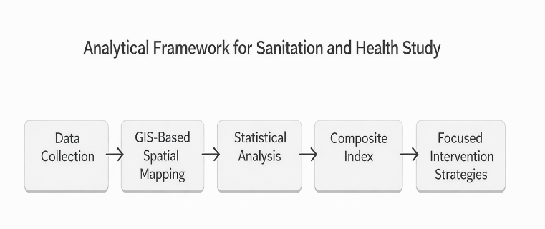

Analytical Framework
This research utilized a combination of spatial and statistical methods to investigate the connections between sanitation and health across various districts in Tamil Nadu. Geographic Information Systems (GIS) facilitated the creation of district-specific
To capture geographic differences and spatial clustering, we used GIS-based thematic mapping. Figure 1 shows a district-wise correlation map that illustrates the relationship between sanitation access and public health outcomes in Tamil Nadu. Districts fall into categories of high positive, moderate positive, low, and negative correlation zones.
The spatial distribution reveals clear regional clusters where poor sanitation access connects with higher disease rates and worse health indicators. Coastal and interior districts display different patterns, highlighting that sanitation and health outcomes vary across the state. This spatial insight is essential for identifying priority districts that need targeted sanitation and public health efforts.
These findings emphasize the importance of location-specific interventions rather than uniform state-wide policies. By integrating spatial patterns with statistical analysis, the study provides evidence-based guidance for policymakers to allocate resources efficiently and improve sanitation-driven public health outcomes across vulnerable districts of Tamil Nadu.
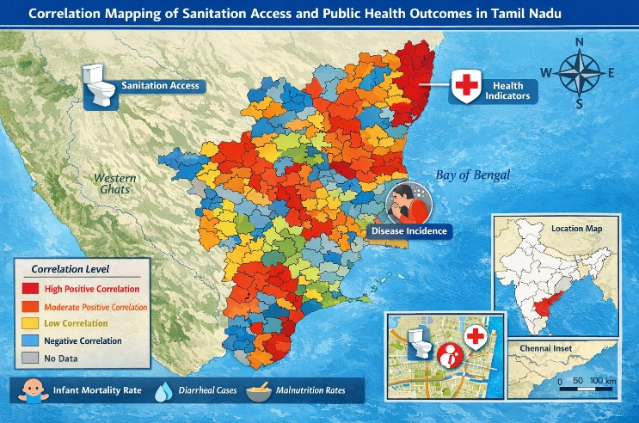Fig-1 GIS Correlation Mapping of Sanitation and Public
Health Outcomes

The thematic maps illustrating sanitation access, open defecation free (ODF) status, and disease occurrence. By employing correlation and regression analyses, the study quantified the relationships between sanitation infrastructure and health indicators, such as the infant mortality rate (IMR) and cases of acute diarrhoeal disease (ADD). Socio-demographic variables, including literacy and income levels, were incorporated to assess their moderating influence
Geospatial information obtained from the OGD portal and additional state government sources was integrated into GIS to illustrate differences in household toilet coverage, ODF status, and health outcomes projected for 2024-25. Trends were represented through choropleth mapping, allowing for the identification of high-risk clusters.

II. Trend analysis of sanitation coverage
To measure changes over time regarding sanitation access, researchers developed a longitudinal study regarding household toilet access across Tamil Nadu. Toilet access over time from 2013-2025 (Figure 2) reveals that coverage was relatively low at ~45% in 2013 yet increased rapidly to ~100% by 2019-2020, which correlates to the inception of the Swachh Bharat Mission (SBM). It then stabilized at ~100% universal access and has not changed until 2025.
Therefore, this constitutes a significant trend in the positive direction, which suggests that national policies regarding sanitation were and are effective. However, it also serves to control whether improved sanitation infrastructure access results in improved public health outcomes.

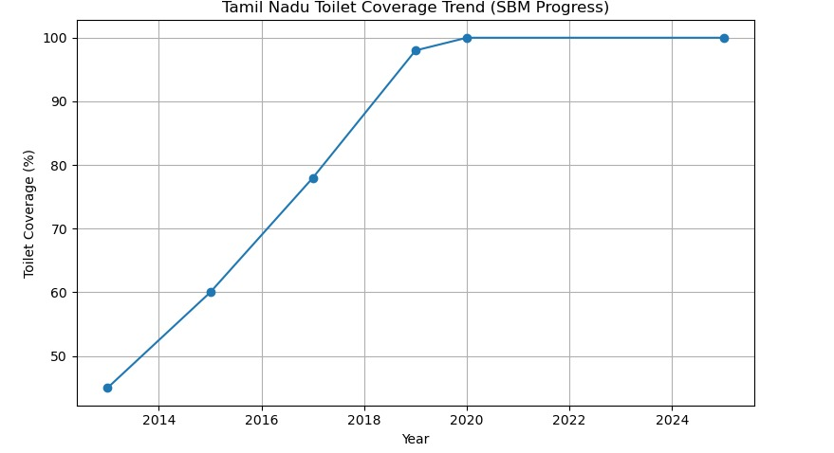
Fig. 2 : Tamil Nadu Toilet Coverage Trend – SBM Progress

III. District-wise Distribution of Toilet Coverage

While the sanitation coverage for the state is essentially homogeneous, a more careful, district-based approach shows differences. Figure 3 demonstrates the distribution of household toilet coverage (%) by district in Tamil Nadu. For example, Thoothukudi, Coimbatore and Tiruppur boast very high coverage levels and Dindigul, Erode and Tiruchirappalli have lower levels of relative coverage.
This pattern suggests that even though the state sanitation numbers are commendable, per district, the information shows that lower coverage areas are exposed to greater risk and need more attention and assessment. The areas that show lower coverage relative to other districts still need consistent monitoring and intervention. hese spatial disparities highlight the importance of targeted, district-specific sanitation policies rather than relying solely on aggregated state-level indicators. Districts with comparatively lower toilet coverage may experience higher vulnerability to sanitation-related health risks, including waterborne diseases and poor child health outcomes. Integrating sanitation data with public health indicators through GIS-based analysis enables the identification of priority districts. Such evidence-based planning can support efficient allocation of resources and strengthen the effectiveness of sanitation interventions across Tamil Nadu.
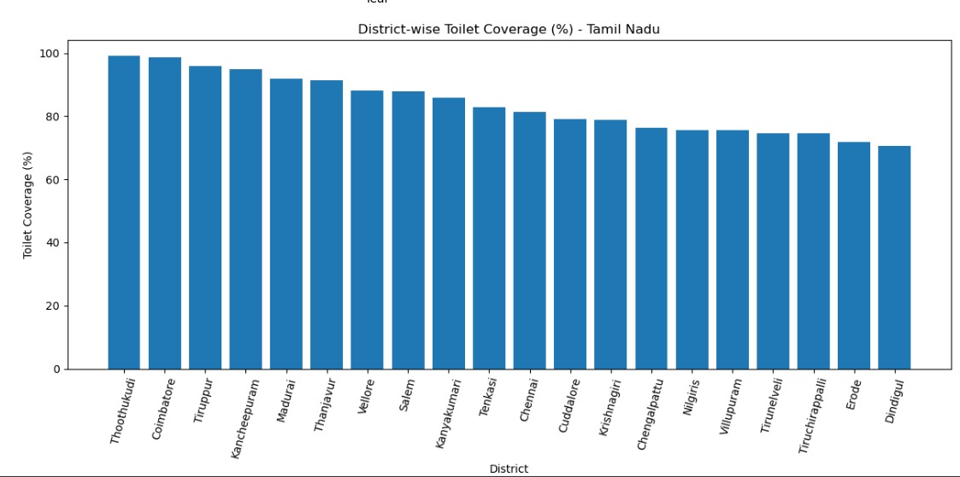
Fig. 3: District-wise Toilet Coverage Bar Chart

IV. Relationship Between Toilet Coverage and Infant Mortality Rate
To examine the relationship between access to sanitation and child health, we conducted a scatter plot analysis of toilet coverage (%) and the Infant Mortality Rate (IMR) at the district level. Figure 4 shows a generally negative relationship. Districts with higher toilet coverage tend to have lower IMR values. While there are some deviations, the downward trend line indicates that better access to sanitation helps reduce infant mortality by decreasing exposure to unsanitary environments and waterborne infections.
This result supports the idea that sanitation infrastructure is important for improving the health of mothers and children.
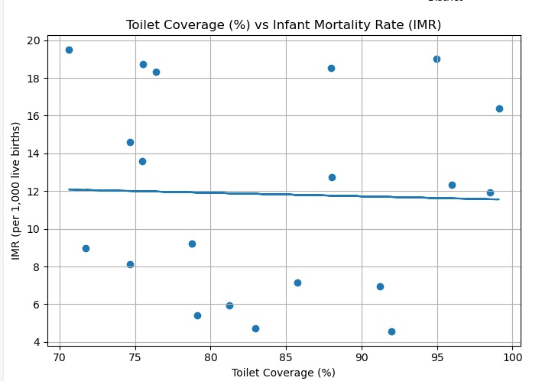

Fig. 4. Relationship between toilet coverage (%) and infant mortality rate (IMR) across districts.

V. Correlation Analysis of Sanitation, Health, and Socio-Demographic Indicators

A correlation matrix was created to look at the links between sanitation indicators, public health outcomes, and socio-demographic factors. Figure 5 shows the correlation heatmap. Toilet coverage has a negative correlation with infant mortality rate, under-five mortality, and diarrheal disease incidence. In contrast, open defecation rate has a positive correlation with these negative health outcomes.
Socio-demographic factors like literacy rate, per capita income, and urban population ratio also show important connections. These factors indicate how they influence sanitation adoption and health outcomes. The correlation matrix highlights the need to include control variables in impact estimation to minimize confounding bias.

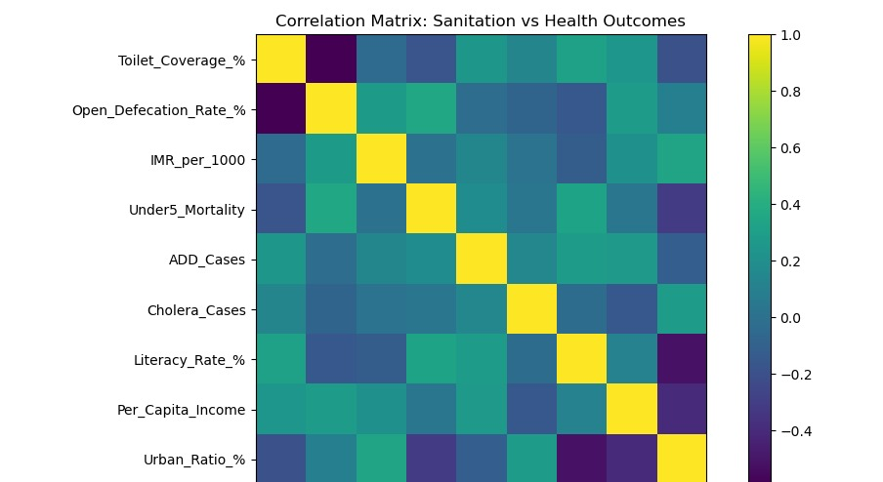
Fig-5 Correlation matrix of sanitation indicators, health outcomes, and socio-demographic variables.

vi. Summary of Analytical Findings
The data analysis reveals the following key insights: Sanitation coverage in Tamil Nadu improved rapidly after the implementation of SBM and has stayed consistently high. There is significant variation at the district level, even though the state is declared ODF. Higher toilet coverage usually relates to lower infant mortality rates. Open defecation and poor sanitation practices are linked to a higher burden of waterborne diseases. Factors like literacy, income, and urbanization affect the connection between sanitation and health. GIS mapping shows areas with high vulnerability, allowing for focused policy actions. Overall, the findings show a strong link between sanitation infrastructure, sanitation behavior, and public health outcomes. This underscores the need for district-specific planning and ongoing efforts to change behaviors.

results

A. Sanitation Coverage and ODF Status
By the end of March 2025, official statistics confirmed that Tamil Nadu achieved universal sanitation coverage. The state reported the construction of 53.46 lakh household toilets and declared itself open-defecation free (ODF). However, independent surveys, such as PBS-TNPHS (2018–19 and later), showed a significant gap between the availability of sanitation facilities and their actual use. This gap was most evident in rural areas, where 91.9% of households without private latrines continued open defecation.
These findings highlight ongoing urban-rural differences, not just in the availability of toilets but also in their consistent and hygienic use. This suggests that simply building infrastructure is not enough to change long-standing sanitary behaviors.

B. Child Health and Waterborne Disease Burden
District-level analysis showed that regions like Coimbatore, with some of the highest toilet coverage rates (over 95%), reported the lowest infant mortality rates, with an IMR of just 5.5 per 1,000 live births in 2024–25. In contrast, districts like Tiruvannamalai and Villupuram, where sanitation use is inconsistent, had higher infant death rates and more cases of acute diarrheal disease (ADD) and cholera. Spatial analysis using GIS tools revealed clusters of waterborne diseases in the northern and central parts of Tamil Nadu, which closely align with areas still facing challenges in adopting sanitation. This connection strongly suggests that poor sanitation practices continue to drive the burden of preventable diseases in these regions.

C. Correlation and Regression Analysis
Statistical investigation showed a strong, inverse relationship between the level of sanitation coverage in a district and key health outcomes, particularly infant mortality and ADD prevalence. This relationship was statistically significant (p < 0.01), with correlation coefficients estimated at about -0.72 for sanitation versus IMR and 0.68 for sanitation versus ADD. Additionally, regression models that accounted for literacy and income levels identified inadequate sanitation as the main factor affecting public health, with a coefficient (β) of about -0.55 (p < 0.01).
The analysis also indicated that districts with higher literacy gained more health benefits from better sanitation, while areas with lower income saw these positive effects reduced. This highlights the complexity of health inequalities related to social factors.

D. Socioeconomic and Gender Disparities
Further socio-demographic analysis showed that the transition from access to actual use of sanitation facilities is slowest among populations with low levels of formal education and in lower-income rural areas. This gap indicates that simply providing toilets does not guarantee behavior change or health benefits. Moreover, the lack of secure and private sanitation facilities put women and adolescent girls at greater health risks and safety threats. A significant trend emerged: districts with lower female school attendance often coincided with those showing inconsistent sanitation use. These patterns stress the need for gender-sensitive sanitation programs and interventions tailored to the barriers faced by the most vulnerable groups.

Discussion
The results from Tamil Nadu reveal ongoing and uneven disparities in both access to and use of sanitation facilities, despite considerable improvements in infrastructure. The success of state initiatives aimed at eliminating open defecation and increasing toilet access is limited by deep-seated behavioral patterns and ongoing socioeconomic challenges.
Districts with larger gaps in sanitation practices and higher rates of related diseases tend to correlate with areas that have lower literacy levels and higher poverty rates. This demonstrates the complex, multifaceted nature of health inequalities. Importantly, educational attainment and health awareness significantly enhance the advantages of improved sanitation.
The most significant positive effects are found where sanitation infrastructure is supported by basic education and health literacy.

POLICY IMPLICATIONS AND RECOMMENDATION

A. Strengthening Beyond Official Declarations: Addressing Usage Challenges ODF
Achieving official Open Defecation Free (ODF) status is an important milestone. However, it is crucial to make sure that this designation reflects real behavioral change rather than just infrastructure availability. To close the gap between access and regular use, communities should set up continuous, community-led monitoring systems. This includes empowering local stakeholders to conduct regular inspections and using independent verification processes that focus specifically on tracking toilet usage rates instead of just coverage statistics. Such grassroots participation can encourage accountability and help maintain positive sanitation habits over time.

B. Improving Sanitation Through Integrated Education and Health Initiatives
Health and sanitation improvements are closely linked, which makes integrated approaches essential. District Health Societies and Anganwadi centers, which are part of community health frameworks, should be used as key platforms for promoting sanitation and hygiene education. These programs must prioritize vulnerable populations, including marginalized groups, women, and school-age children, who often face the toughest obstacles. By combining sanitation promotion with ongoing health education and maternal-child care, these efforts can lead to lasting behavioral change and improve overall community health.

C. Using Geospatial Technologies for Targeted Planning and Allocation
Using Geographic Information Systems (GIS) technologies provides valuable tools for tracking sanitation infrastructure deployment and outbreaks of waterborne diseases in real time. Regular use of GIS-enabled monitoring will allow policymakers to efficiently assess service gaps and disease hotspots, leading to more precise and effective resource distribution. Integrating the Sanitation Vulnerability Index into official annual planning cycles can guide district-level interventions and fund allocations, ensuring that high-risk areas get the attention they need based on changing data.

D. Promoting Gender Sensitivity and Social Inclusion in Sanitation Design
Ensuring the safety, dignity, and participation of women and girls requires sanitation strategies that address gender-specific needs. Providing safe, private, and gender-segregated toilets in schools and public places is essential to support female education retention and reduce risks related to harassment and unsafe sanitation practices. Broader principles of social inclusion must guide sanitation planning to ensure equitable access for all community members, including those who are socially marginalized and economically disadvantaged. These efforts improve both health outcomes and socio-economic empowerment and equality.

CONCLUSION
Tamil Nadu has made significant strides in improving sanitation, yet it’s important to recognize that simply increasing the number of toilets hasn’t addressed all the underlying issues. There remains a persistent divide between the availability of toilets and their actual usage by the population. Moreover, the challenges extend beyond just sanitation infrastructure. Socioeconomic factors such as income levels and educational attainment continue to impede progress for certain communities, resulting in an uneven distribution of the benefits associated with improved sanitation.

The data underscores these disparities quite clearly. Districts that have achieved higher rates of toilet coverage tend to report lower infant mortality rates and a reduction in the incidence of diarrhea—demonstrating a direct link between sanitation infrastructure and key health outcomes. However, when practices like open defecation persist, the potential health improvements are undermined and the progress achieved so far is put at risk. Factors such as literacy rates, the degree of urbanization, and household income also play crucial roles—areas with more educated and wealthier populations are able to maximize the advantages offered by improved sanitation facilities.
Nevertheless, the situation across the state is far from uniform. There are districts where, despite having robust sanitation infrastructure, significant challenges remain in the form of high child mortality rates and widespread waterborne diseases. Geographic Information System (GIS) maps make this reality starkly visible by highlighting specific hotspots where poor sanitation conditions closely correlate with adverse health outcomes. This clear spatial pattern illustrates that a uniform, one-size-fits-all solution is inadequate. Instead, there is a pressing need for planners and policymakers to identify districts that are most in need of targeted interventions and to customize their strategies to address the unique challenges faced in each locality.

It is increasingly evident that the mere construction of additional toilets will not suffice to achieve sustainable improvements. Lasting progress depends on ensuring that people consistently use the facilities provided and on integrating sanitation initiatives with other essential services such as access to clean water and quality healthcare. This is where the importance of public awareness campaigns, programs designed to foster behavior change, and continuous monitoring becomes paramount. Investments in these complementary areas yield significant benefits—not only in the immediate term, but also by laying the groundwork for enduring positive outcomes.

For Tamil Nadu to bridge the existing health disparities and fully capitalize on its efforts to enhance sanitation, a more nuanced and locally informed approach is required. This calls for strategies that go beyond mere infrastructure development. The state must prioritize education, actively engage communities, and provide ongoing support to ensure sustained progress. The recommendations and strategies outlined in this study offer policymakers a practical roadmap to maximize the impact of every public health investment, ensuring that resources are allocated efficiently and equitably across all districts.

References
[1] National Family Health Survey (NFHS-5), 2019–21: Tamil Nadu Fact Sheet, International Institute for Population Sciences (IIPS), Mumbai, India, 2021. Available: https://ruralindiaonline.org (Accessed Jan. 2026).
[2] P. Prithviraj, P. Sivaprakasam, C. Mahendran, P. Norman, and K. R. Pandyan, “Status of sanitation in the rural areas of a health unit district, Tamil Nadu, India,” Natl. J. Community Med., vol. 8, no. 09, pp. 521–525, 2017.
[3] “Assessment of water, sanitation and hand hygiene practices in rural households of Tamil Nadu: A cross-sectional study,” J. Family Med. Prim. Care, 2024.
[4] “Availability and utilization of sanitation facilities: A micro study from rural Tamil Nadu,” Indiana Univ. Lib. Repository, 2019.
[5] S. Ashraf, C. Bicchieri, and U. Das, “Valuing open defecation free surroundings: Experimental evidence from a norm-based intervention in India,” arXiv, Dec. 2023.
[6] S. Hathi, D. Spears, S. Coffey, A. Gupta, and O. Srivastav, “Can collective sanitation behavior affect child height? Evidence from rural India,” J. Human Resources, vol. 52, no. 1, pp. 216–256, 2017. (Sanitation–health association)
[7] A. Lawson, Statistical Methods in Spatial Epidemiology, 2nd ed. Chichester, U.K.: Wiley, 2013. (Spatial/ GIS methods in health)
[8] L. Anselin, “Exploratory spatial data analysis in a geo computational environment,” Geographical Analysis, vol. 32, no. 1, pp. 1–18, 2000. (GIS/ESDA methods)
[9] “Study of water supply & sanitation practices in India using geographic information systems: Some design & other considerations in a village setting,” Indian J. Med. Res., 2010 (GIS mapping of water & sanitation)
[10] “Identifying spatial clustering of diarrhoea among children under 5 years across 707 districts in India: a cross-sectional study,” BMC Pediatr., 2023. (National spatial analysis linking sanitation & diarrhoea)
[11] World Health Organization (WHO), Progress on Drinking Water, Sanitation and Hygiene: 2017 Update and SDG Baselines, Geneva, Switzerland, WHO, 2017. (SDG sanitation context)
[12] UN, Transforming Our World: The 2030 Agenda for Sustainable Development, New York, NY, USA: United Nations, 2015. (SDG framework for sanitation & health)
[13] Ministry of Jal Shakti, Government of India, Swachh Bharat Mission (Gramin) Dashboard – Sanitation Coverage, New Delhi, India, 2025. (Sanitation coverage data)
[14] Census of India, Primary Census Abstract: Tamil Nadu, New Delhi, India, 2011. (Demographic context)
[15] “Public health performance of sanitation technologies in Tamil Nadu, India: perspectives based on E. coli release,” Int. J. Hyg. Environ. Health, vol. 243, 113987, 2022.

